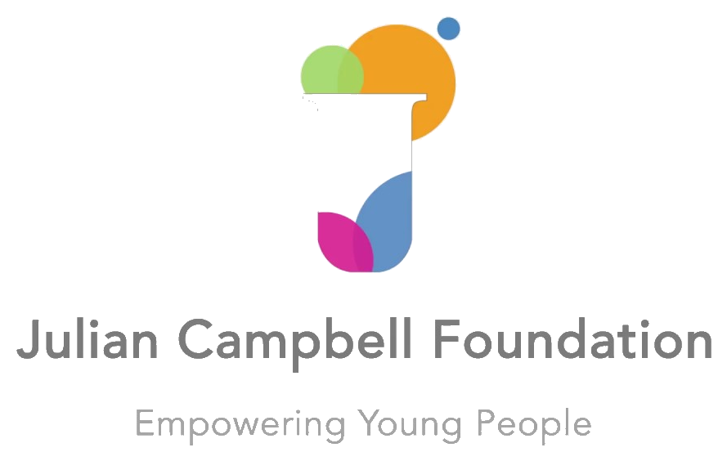
Understanding Your Teen's Mood
A Parent's Guide to the JCF Mood Map
UK EDITION
FIND OUT HOW TO READ YOUR TEEN'S MOOD —
AND YOUR OWN — SO YOU CAN SHOW UP CALM WHEN IT COUNTS
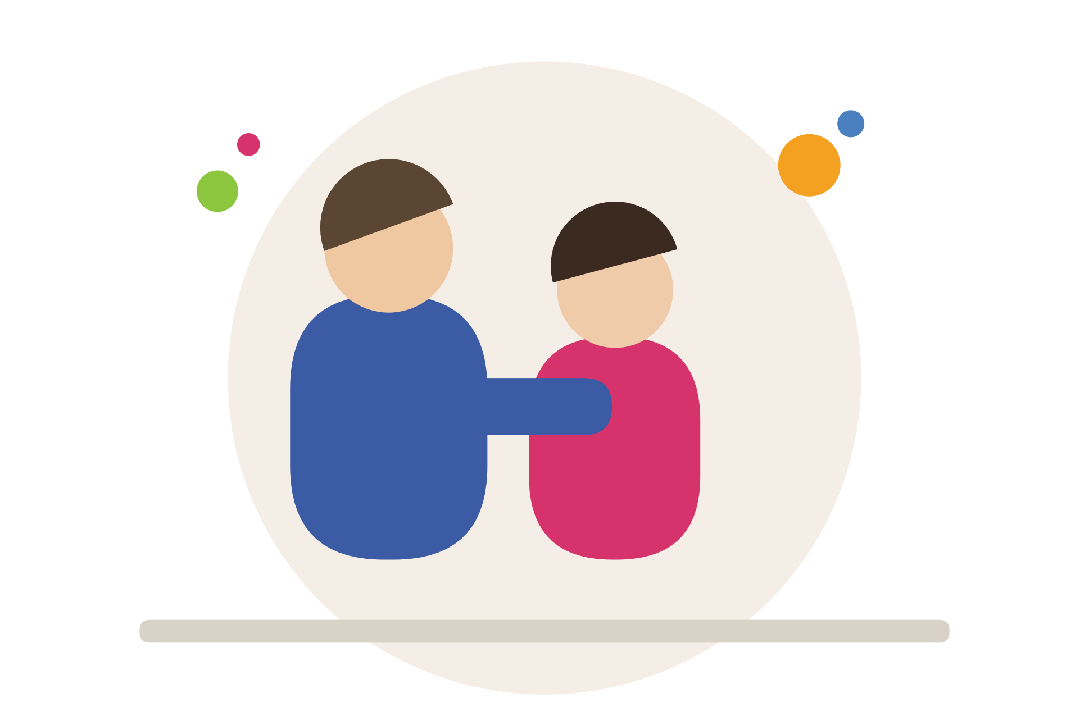
Companion guide to the JCF Mood Map booklet for young people.

Why I Created This Guide
I first started using the mood map myself, long before it became something we gave to young people.
About fifteen years ago I was living with what turned out to be chronic fatigue, although I didn't have a name for it at the time. I was completely results-driven — I'd think nothing of drinking a Red Bull, or getting through the day on coffee after coffee, just to keep going. Looking back, it built up over about two years: going to bed earlier, waking up later, needing more and more just to function. Then one day, I simply couldn't get up. For about eight months, I assumed more sleep would fix it. It didn't.
I was introduced to the mood map after seeing Dr Liz Miller on a Stephen Fry documentary, and later managed to meet her — she went on to become a trustee of this charity. Her book, Mood Mapping, changed how I understood myself. I started tracking my own mood four times a day, and for the first time I began to see patterns I'd never noticed before — when tiredness was building long before I felt it, what actually helped shift a low mood, and what didn't. I built a toolbox of things that worked for me, which I'd never had before.
Dr Miller's background was medicine and surgery; mine was teaching. Between the two of us, we took her clinical model and shaped it into something we could use in mentoring and in the classroom.
The one gap was that her original model was built for adults — there was nothing for children. Around the same time, I came across the work of Yale's Center for Emotional Intelligence, who had developed their own version for young people and parents, using colour to make the four states instantly visible. So we brought the two together, worked with a group of teenagers to shape the language, and that became the JCF Mood Map you've seen throughout this guide.
It's been the cornerstone of our work with young people ever since — and it has been just as useful for illustrating the flexibility of moods and emotions, and how we manage them, to adults.
It still works the way it worked for me: not by fixing a mood, but by helping you see it clearly enough to know what to do next.
— Jacqui Campbell
Founder, Julian Campbell Foundation
The JCF Mood Map is JCF's own adaptation, created together with a group of teenagers for use in our mentoring and teaching resources. It draws on ideas from Dr Liz Miller's Mood Mapping method and Yale Center for Emotional Intelligence's Mood Meter — JCF is not affiliated with, and does not claim ownership of, either of those original models.

When Your Teen Goes Into a Mood, So Do You
This guide accompanies Parts 1 and 2 of JCF's Inside the Teenage Mind series. If you haven't already, watch the videos first — then use the seven-day reflection pages at the end of this guide to put the ideas into practice.
Most parents don't struggle with their teenager because they don't care. They struggle because in the moment, they're triggered.
Your teen slams the door — and you feel disrespected. Your teen says "I'm fine" — and you feel shut out. They're glued to their phone — and you feel powerless.
Here's the shift that changes everything: when your teen goes into a mood, consider that you go into a mood too. Every human being moves through mood states, not randomly, but in patterns — and once you can see those patterns, on both sides, you can respond instead of react.
Calm is contagious. So is chaos.
This guide uses the same JCF Mood Map your teen already knows from their own booklet — but turns it around. Before we can help our teens manage their moods, we first need to understand what's happening in us.

The JCF Mood Map — A Quick Refresher
Mood is a mixture of two things:
- How positive (nice) or negative (rubbish) you're feeling (pleasantness)
- How much or how little energy you have
The map is divided into four zones. When you can name where you are — and where your teen is — you can choose your next move instead of being run by it.
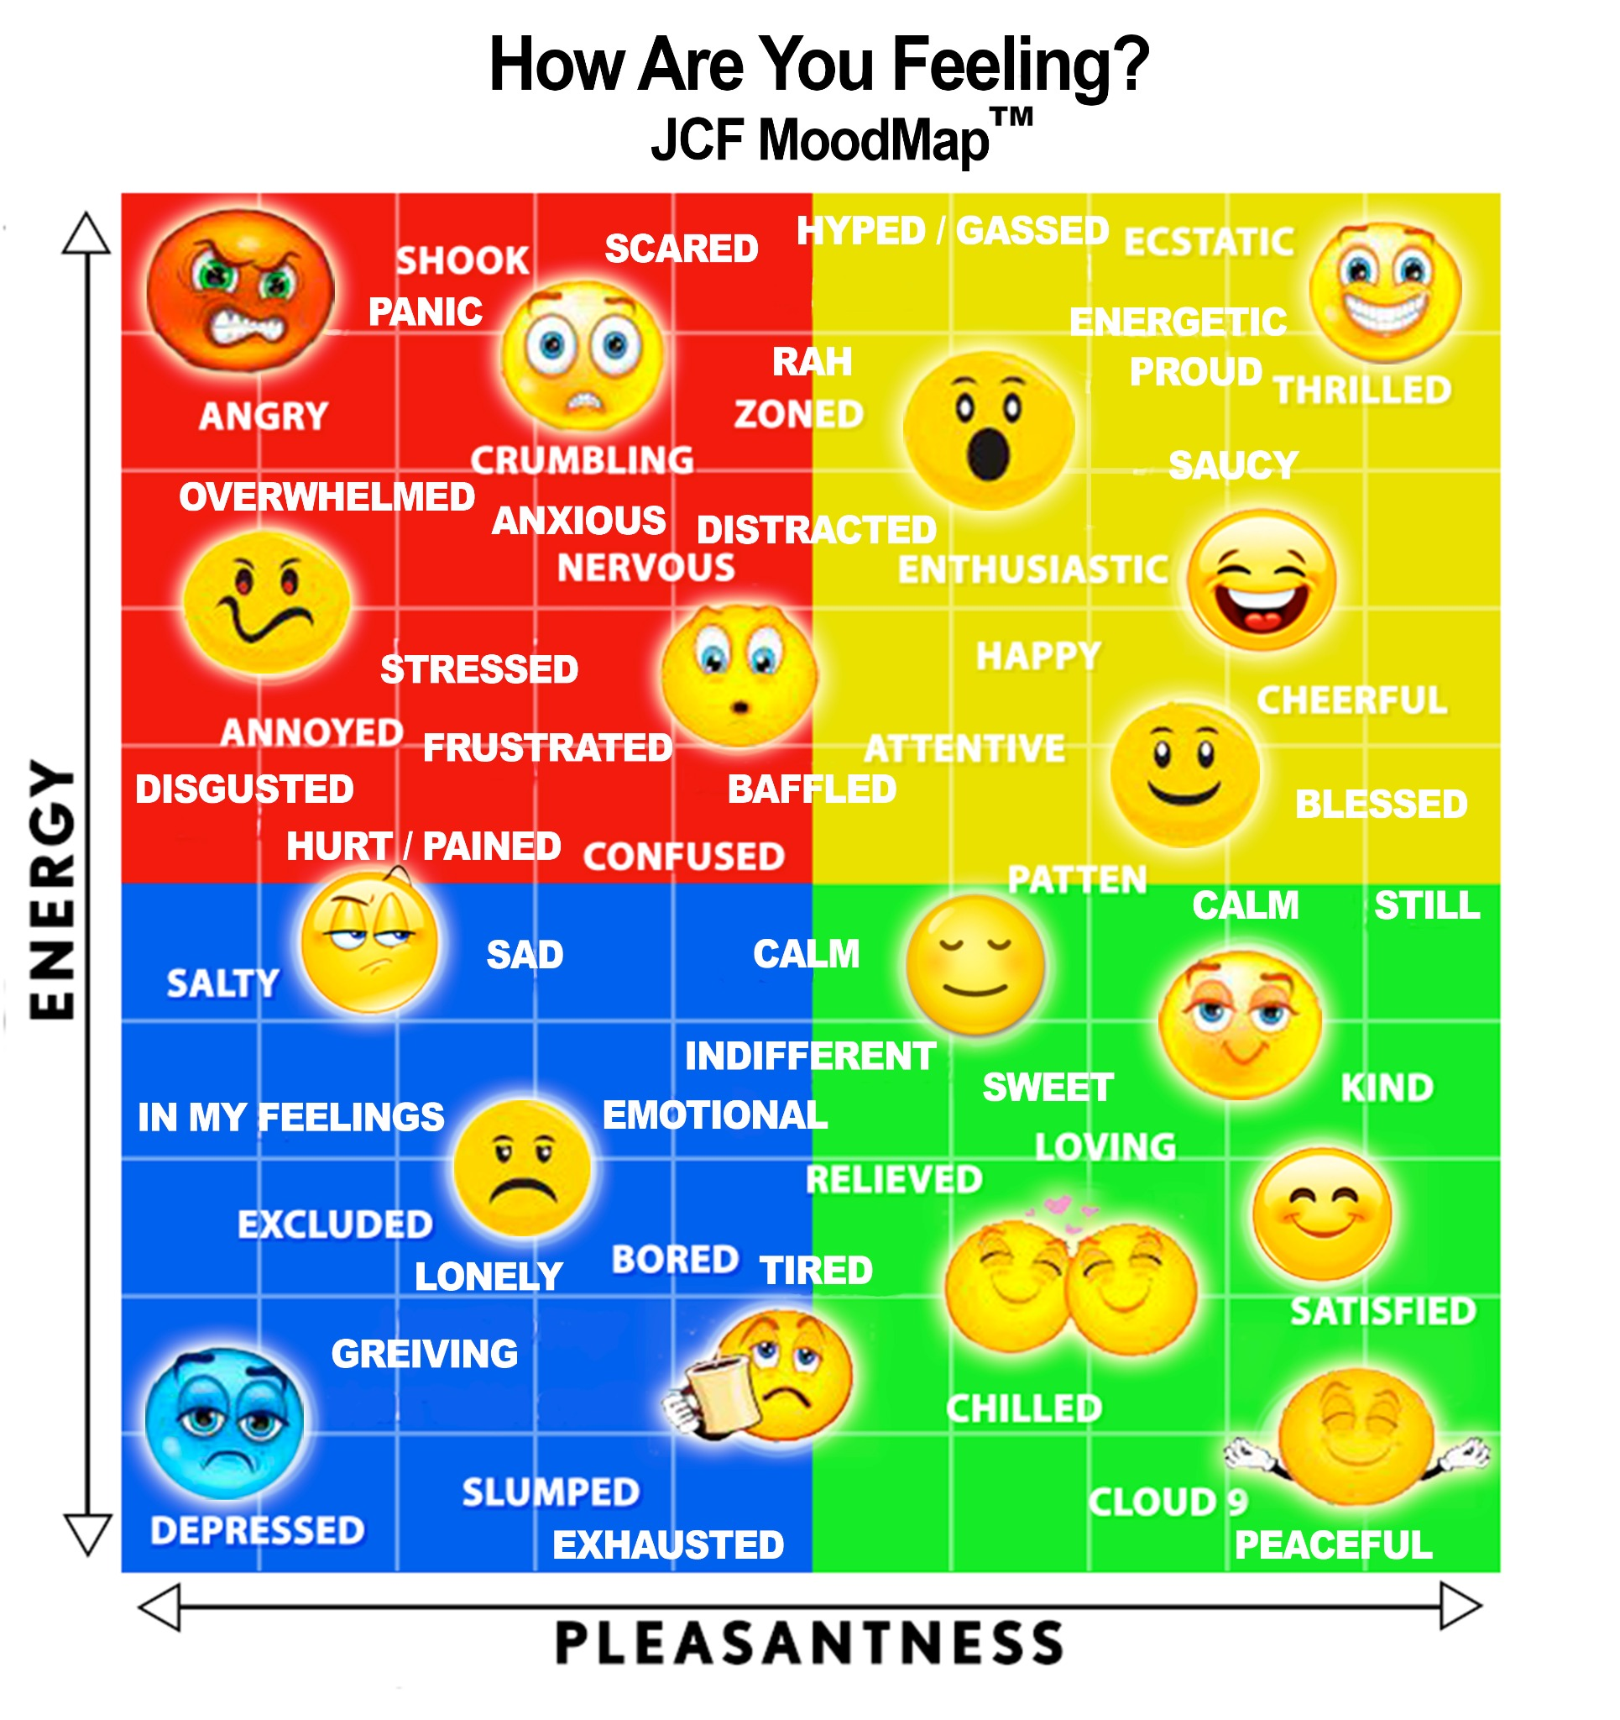

When we feel threatened or overwhelmed, the body's stress response can make calm reflection and communication more difficult. When we feel safer and more settled, it is usually easier to listen, think clearly and reconnect. That's true for the red and blue zones as much as it is for us as parents.

Where Do YOU Go When Your Teen Is Difficult?
Before you can read your teen's mood, it helps to notice your own reflex. Ask yourself:
- When your teen shuts down, do you go into the red (anxious, stressed) or the blue (down, weary)?
- When your teen is rude, does it put you up in the red — angry, incensed, overwhelmed?
- When your teen is distant, does it drop you into the blue — rejected, dejected?
There's nothing wrong with visiting the red or blue zones — everyone does, often several times a day. The trouble starts when a stressed or shut-down state carries on for weeks, months or years, because our bodies and minds aren't built to sustain that, and it shows up as real strain — on health, attention and decision-making.
And here's the practical catch: when you're feeling threatened or overwhelmed, calm reflection and communication get harder — wherever that shows up on the map. Trying to talk through something big from that place rarely goes anywhere good. The first move isn't to fix your teen's mood. It's to notice your own.

Using the Mood Map in Real Life: Six Steps
Here are the six steps for putting the mood map into practice the next time your teenager shuts down, gets angry, or retreats into their phone.

STEP 1 Notice the Mood — Don't React
Look at the mood, not the behaviour.
When your teen is withdrawn on their phone with a blank look, that withdrawal isn't disrespect — it might be overwhelm.
Before responding to what they did, pause and ask: what mood are they actually in right now?

STEP 2 Regulate Yourself First
Notice your own state before you speak.
Find where you are on the map before you speak. If you're in the red — high energy, rubbish mood — you're not yet in a state to have a calm conversation.
Try: deep breathing, lowering your voice, stepping away for a moment, phoning a friend, or going for a walk.
Calm is contagious — and so is chaos. Regulating yourself first is what makes everything after this actually work.

STEP 3 Meet Them Where They Are
Recognise the emotion before addressing the behaviour.
Meeting them where they are doesn't mean agreeing with everything they say, or accepting disrespect. It means naming the feeling first.
If they're angry (in the red), their stress response is running the show right now — not a state for reasoning. Give it a moment.
TRY SAYING:
“I can see you don't feel like talking. I'm here when you're ready. No pressure.”
“I can see you're a bit upset. Let's give this a moment and talk when it's calmer.”
“I know you're saying you're fine, but I'm noticing you don't seem yourself. How's your day really been?”

STEP 4 Listen to the Emotion Behind the Words
Active listening means hearing what's underneath.
"I don't care" can mean I care so much I feel overwhelmed. "Leave me alone" can mean I need space, don't abandon me. "Whatever" can mean I don't know how to explain how I feel.
Rather than questioning or advising, try reflecting back — then pause. Silence can be the space where they finally feel safe to speak.
TRY SAYING:
“It sounds like your day's been difficult.”
“You seem disappointed — have I got that right?”
“It sounds like nobody was listening to you.”

STEP 5 Help Them Regulate — Don't Control
Co-regulation, not correction, comes first.
The mood map isn't about forcing your teen to be happy — every mood on it is a normal part of being human. The question isn't "how do I make this mood disappear?" It's "what does this young person need right now?"
Offering choices helps them build the skill of recognising and managing their own state — with your calm alongside them.
TRY SAYING:
“Where are you on the mood map right now?”
“What's one small step that might help you feel a bit calmer?”
“Would you like space, a drink, music, a walk — or would you like me to sit with you?”

STEP 6 Reconnect, Reflect, Then Correct
Connection comes before correction.
Once you're both calmer, return to what happened. This is where boundaries and conversations belong — not in the heat of the red or blue zone.
If a boundary was crossed, address it clearly and without humiliation: name the feeling as valid, name the behaviour as the issue.
TRY SAYING:
“Can we talk about what happened earlier? What was going on for you in that moment?”
“What helped you start to feel calmer? What could we both do differently next time?”
“I understand you're angry, and it's okay to feel angry. It's not okay to speak to me that way — let's find another way for you to tell me what you need.”

Before You Speak
This is the pause from Step 2, pulled out on its own page — somewhere quick to turn to in the moment, before you knock on that door or reply to that comment.

BEFORE YOU SPEAK: A 60-SECOND PAUSE
When you feel the urge to respond right away, pause and ask yourself:
1. What am I feeling right now?
2. What story am I telling myself about what just happened?
3. What does my teenager possibly need in this moment?
4. Does this conversation need to happen right now — or can it wait until we're both calmer?
There's no wrong answer. The pause itself is the point — it moves you from reacting to choosing.

A Worked Example: "I'm Not Talking About It."
Here's one realistic situation taken all the way through the six steps.
Your teenager comes home from school, doesn't answer when you ask how their day was, and slams their bedroom door. You feel a flash of hurt and disrespect — after everything, they can't even say hello.

STEP 1 · Notice the Mood — Don't React
The slammed door feels like disrespect. But look at the mood, not just the behaviour: withdrawn, silent, refusing to engage often sits in the blue zone (low energy, low mood) — not the red. Something has drained them, not fired them up.

STEP 2 · Regulate Yourself First
Your own reaction is real — "After everything I do, this is the thanks I get" is the kind of story that pulls you into the red zone. Before knocking on the door, take a breath, unclench your jaw, and give yourself thirty seconds. You're no use to either of you if you arrive at that door already in the red.

STEP 3 · Meet Them Where They Are
Knock gently rather than barging in. "I can see you don't want to talk right now. I'm here when you're ready. No pressure." Then leave a genuine gap — even if it's uncomfortable.

STEP 4 · Listen to the Emotion Behind the Words
If they later say "Everyone hates me, what's the point," resist the urge to problem-solve immediately. Reflect it back instead: "It sounds like today was really hard." Let them fill the silence.

STEP 5 · Help Them Regulate — Don't Control
Rather than demanding they explain themselves right away, offer choices: space, a drink, sitting together in silence, a walk. "Would you like space, or would you like me to sit with you for a bit?"

STEP 6 · Reconnect, Reflect, Then Correct
Once you're both calmer — maybe later that evening — revisit it: "Can we talk about earlier? What was going on for you?" If the door-slamming itself needs addressing as a boundary, do that separately from the original hurt: "I understand you were upset. Slamming doors isn't okay in our house — let's find another way for you to show me you need space."

Notice what changed: the situation itself didn't. What changed was the sequence — mood first, meaning second, correction last.

Putting It All Together
Next time your teenager shuts down, gets angry, or retreats into their phone:
- 1. Notice their mood — instead of reacting to their behaviour.
- 2. Regulate yourself — find your own place on the map first, and move toward yellow or green before you speak.
- 3. Meet them where they are — name the emotion before addressing the behaviour.
- 4. Listen for the feeling beneath the words — reflect it back, then pause.
- 5. Help them regulate without controlling — offer choices, not fixes.
- 6. Reconnect, reflect, then correct — boundaries land once you're both calm.
Your teenager doesn't need a perfect parent. They need somebody who's present.
The role isn't to fix every mood — it's to not lose yourself in theirs. And when a young person feels emotionally safe, they're far more likely to let you into their world.

What This Guide Is — and Isn't
The JCF Mood Map is a communication tool. It gives you and your teenager a shared language for everyday ups and downs, and a starting point for conversation. It is not a diagnostic tool, and it isn't designed to assess crisis or risk.
Please seek professional support if you notice any of the following — rather than waiting to see if the mood map helps first:
- Persistent withdrawal that doesn't lift over days or weeks
- Any talk of self-harm or suicidal thoughts
- Major changes in eating or sleeping
- Not being able to function day-to-day — school, friendships, basic routines
The NHS advises approaching a GP, school nurse, teacher, or your local children and young people's mental health service for further support — see NHS: where to get support for more detail.
If you're ever worried about your teenager's immediate safety, treat it as an emergency: call 999 or go to A&E. If you need urgent mental health support that isn't an emergency, contact NHS 111 and select the mental health option.
This guide is a UK edition and references UK services. If you're reading this outside the UK, please contact your own local emergency number or a local mental health crisis service instead.

Try It Out
This mirrors the seven-day mood chart in your teenager's own booklet. Each time you have a difficult moment with your teen this week, come back to this page and work through it using the mood map — the more you practise, the quicker you'll get at spotting both moods in real time.
DAY 1
WHAT DID THEY DO?

THEIR MOOD | YOUR MOOD
One thing to try next time:

DAY 2
WHAT DID THEY DO?

THEIR MOOD | YOUR MOOD
One thing to try next time:

DAY 3
WHAT DID THEY DO?

THEIR MOOD | YOUR MOOD
One thing to try next time:

DAY 4
WHAT DID THEY DO?

THEIR MOOD | YOUR MOOD
One thing to try next time:

DAY 5
WHAT DID THEY DO?

THEIR MOOD | YOUR MOOD
One thing to try next time:

DAY 6
WHAT DID THEY DO?

THEIR MOOD | YOUR MOOD
One thing to try next time:

DAY 7
WHAT DID THEY DO?

THEIR MOOD | YOUR MOOD
One thing to try next time:

End of Week Reflection
Once you've filled in a few days, take a few minutes to look back over the week as a whole.
WHAT PATTERN DID YOU NOTICE IN YOUR TEENAGER'S MOODS?

WHAT USUALLY TRIGGERS YOUR OWN REACTION?

WHAT HELPED YOU RECONNECT?

WHICH WORDS OR APPROACHES WORKED BEST?

WHAT WILL YOU TRY NEXT WEEK?

DO YOU NEED ANY ADDITIONAL SUPPORT?

As you continue, you'll get quicker at recognising both moods in the moment — yours and theirs.

Your Next Step
This map isn't only a tool for young people — it's also a mirror for us as adults. It helps us recognise what's happening within us, so we don't bring our own fear, anger, or hurt into an already difficult moment.
When a young person feels emotionally safe, they are far more likely to let you into their world.
Reading is a start. Here's one small step you could take this week — tap the link or scan the code:

Watch Parts 1 and 2  Inside the Teenage Mind — the videos this guide is based on.  Watch on YouTube → | 

Join a parent workshop  Book a place on our next JCF parent session.  Book a workshop → | 

Enquire about mentoring  Ask about Mood Map mentoring for your teenager.  Enquire now → | 

Download the young person's booklet
So you're both using the same language.
Find out more →

Join the parent mailing list  Further tips and resources, straight to your inbox.  Sign up → | 
Get in touch to find out more about any of these, or if your family needs further support.
WWW.JULIANCAMPBELLFOUNDATION.ORG
Empowering Young People

